Share content in a meeting in Teams
To share your screen in a meeting, select Share in your meeting controls. Then, choose to present your entire desktop, a window, a PowerPoint file, or a whiteboard.
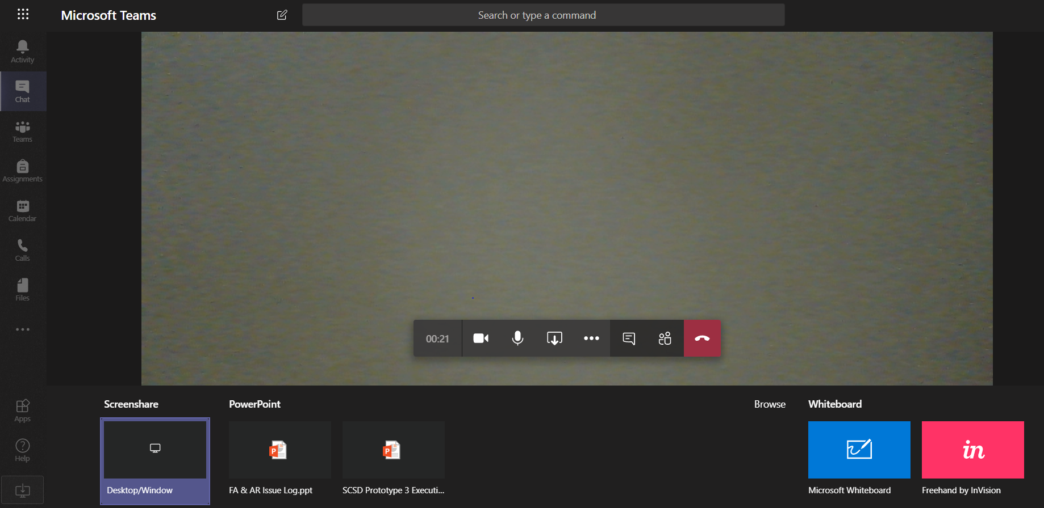
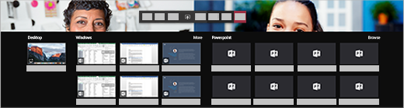
Example of options to present, i.e. Desktop or PowerPoint

Share your... | If you want to... | Great when...
Desktop | Show your entire screen, including notifications and other desktop activity | You need to seamlessly share multiple windows
Window | Show just one window, and no notifications or other desktop activity | You only need to show one thing and want to keep the rest of your screen to yourself
PowerPoint | Present a PowerPoint file others can interact with | You need to share a presentation and want others to be able to move through it at their own pace
Whiteboard | Collaborate with others in real time | You want to sketch with others and have your notes attached to the meeting

When you're done sharing, go to your meeting controls and select Stop sharing.
Note: If you're using a Mac, you'll be prompted to change your privacy settings before you're able to share your screen.

Include system audio
Sharing your system audio lets you stream your computer audio to meeting participants through Teams. You can use it to play a video or audio clip as part of a presentation.
To share your system audio, select Share in your meeting controls and then Include system audio. When you share, all your system audio, including notifications, will be included in the meeting. For more on sharing system audio, check out Share system audio in a Teams meeting.
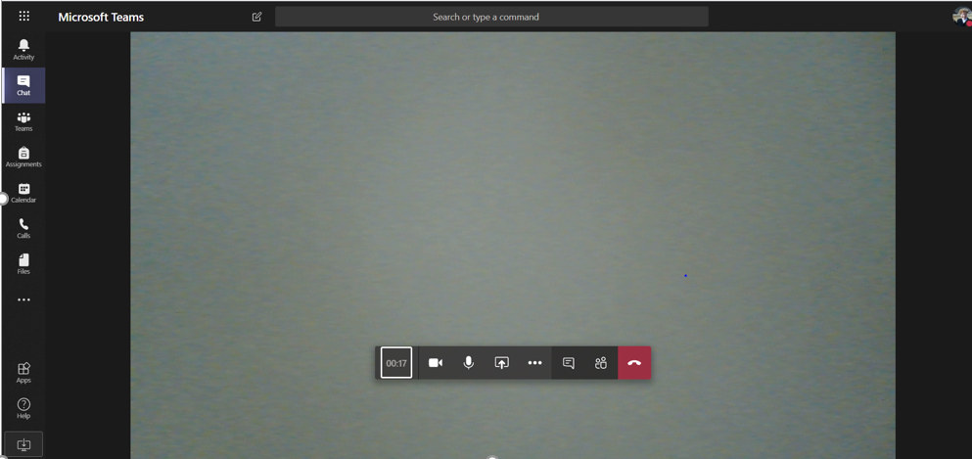
Note: For now, we only support sharing system audio on Windows devices.

Share PowerPoint slides in a meeting
If you choose to share a PowerPoint file in a meeting, participants will get some special capabilities:
- They'll be able to move around to different slides without interrupting the main presentation.
- They can sync their view back to the presenter's view with one click.
- Select Share in your meeting controls.
- In the PowerPoint section, select the file you want. Select Browse to find a different file.
Notes:
  - The PowerPoint section lists the most recent files you've opened or edited in your team SharePoint site or your OneDrive. If you select one of these files to present, all meeting participants will be able to view the slides during the meeting. Their access permissions to the file outside of the meeting won't change.
  - If you select Browse and choose to present a PowerPoint file that hasn't been uploaded to Teams before, it will get uploaded as part of the meeting. If you're presenting in a channel meeting, the file is uploaded to the Files tab in the channel, where all team members will have access to it. If you're presenting in a private meeting, the file is uploaded to your OneDrive, where only the meeting participants will be able to access it.

Give and take control of shared content
Give control
If you want another meeting participant to change a file, help you present, or demonstrate something, you can give control to that person. You will both be in control of the sharing, and you can take back control anytime.
- On the sharing toolbar, select Give control.
- Select the name of the person you want to give control to.
Teams sends a notification to that person to let them know you’re sharing control. While you’re sharing control, they can make selections, edits, and other modifications to the shared screen.
- To take control back, select Take back control.

Take control
To take control while another person is sharing, select Request control. Then, the person sharing will approve or deny your request.
While you have control, you can make selections, edits, and other modifications to the shared screen.
When you’re done, select Release control to stop sharing control.

